Quarter Three

**Law of Exponents** zero exponents

**ANYTHING TO THE**

**POWER OF ZERO EQUALS 1**

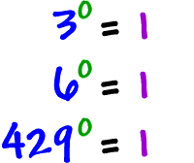

**EVEN FRACTIONS!!!!!** The denominator can never be zero, in general, for ANY fraction, ever, ever, ever, that is called **undefined**. We literally can’t define it!!! So that scenario doesn’t exist to us as mathematicians.

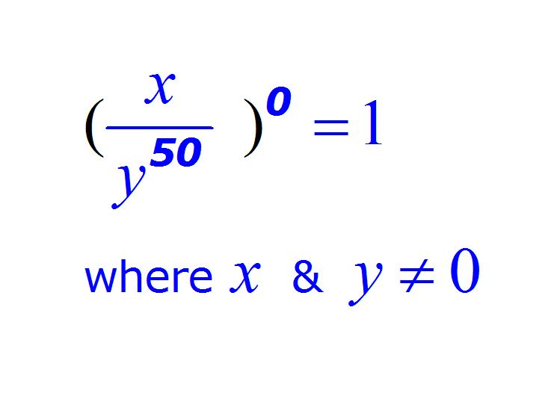

**Negative Exponents** in general

**They are FRAC 🡪 TIONS**

First, Write a fraction with a

1. **in the numerator**

Then, **Re-write the expression in the denominator,** but the **exponent is now positive.** See below**.**

(Math Language: Find the positive reciprocal)

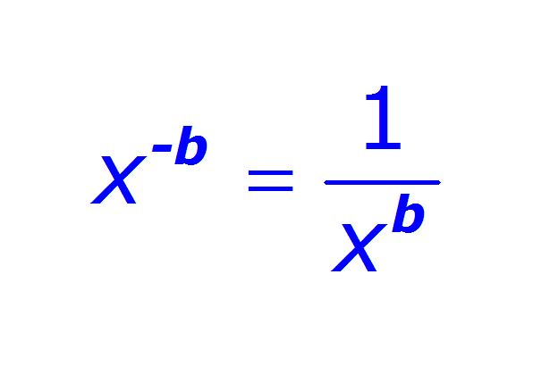

Another negative exponent example below.

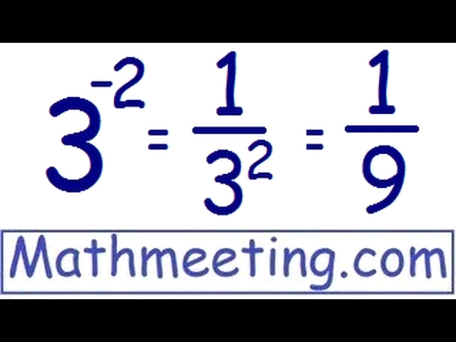

**Laws of Exponents** in general

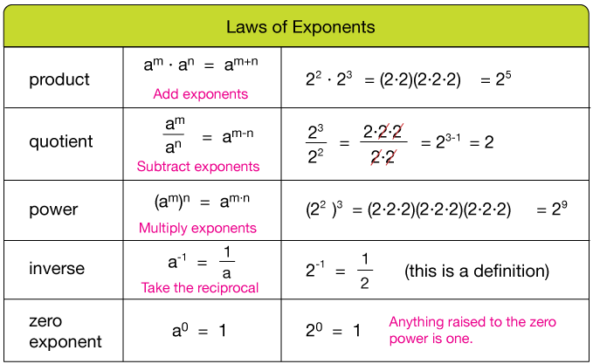**Some Examples**

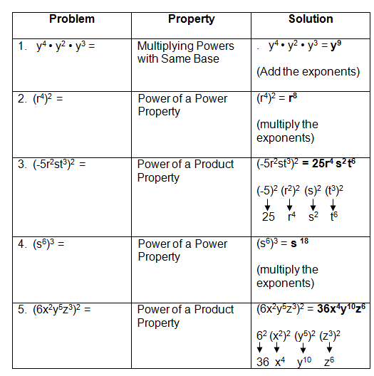

**Exponential Growth**

Functions that grow or shrink exponentially 🡪 Go to infinity fast, or go to negative infinity fast. Below is an example of an exponential function. Notice the difference in the slope from a linear function.

**Expontential 🡪 Curvey** **Linear 🡪 Straight**

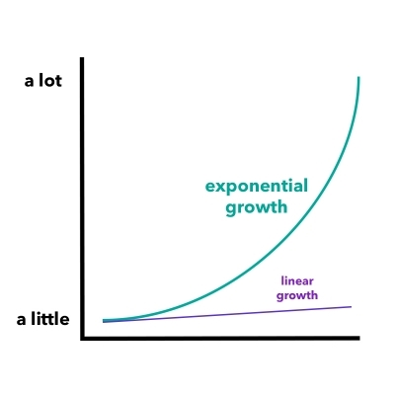

The values on the Y-Axis either get very large quickly, or get very small quickly.

**Exponential Functions**

All of these function have one very specific thing in common. They all have the **variables in the exponent** of the function. Look at the examples below and notice where the “X” is in all of them.

The Set Up**: a (b) x**

**a=** Represents the **initial value,** we have also called this the head start, and the y-intercept.

**b=** Represents the **growth factor** or growth rate. Notice the name….growth **factor,** this is the value we are **multiplying** by each time. Because we multiply factors. It is similar to slope and rate of change, but in tables it’s a multiplicative (multiply) relationship.

**X=** Represents **the variable** (the input)

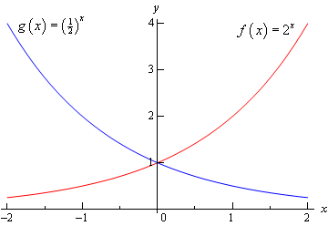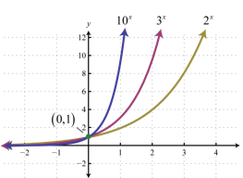

**Percent Review**

**Per** For each, for every, for one of something **Cent** 100

Translation: **For each 1oo** So, a number like 50% means, 50 out of 100

To change a percent into a decimal number we can just divide by 100, because that’s the definition of a percent. Often we just move the decimal 2 spaces left.

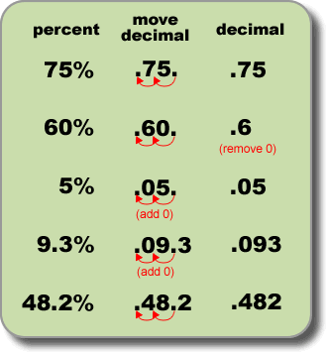

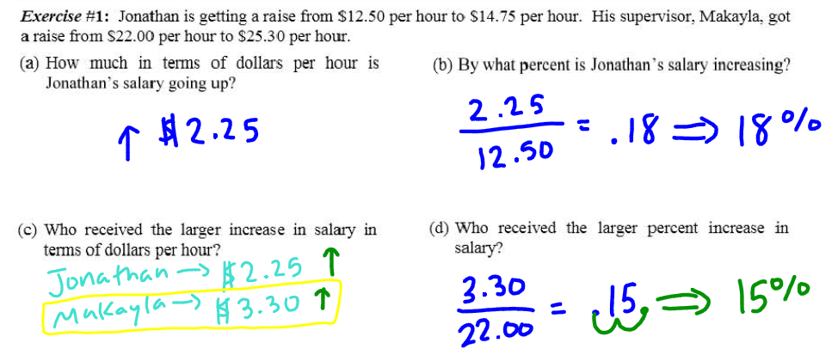 Proportions are comparisons, above in part (b) we are comparing the increase in pay ($2.25) to what our pay originally was (12.50). We talk more about increase and decrease in the next lesson.

**Percent Increase and Decrease**

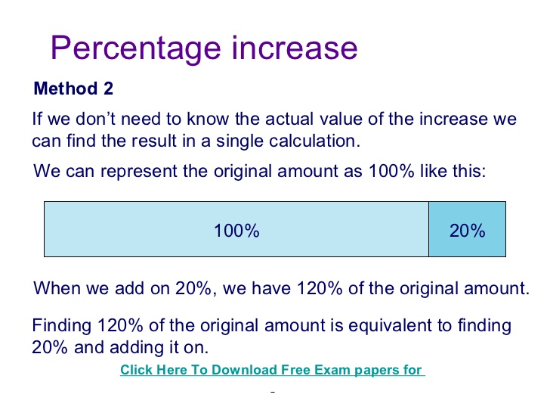

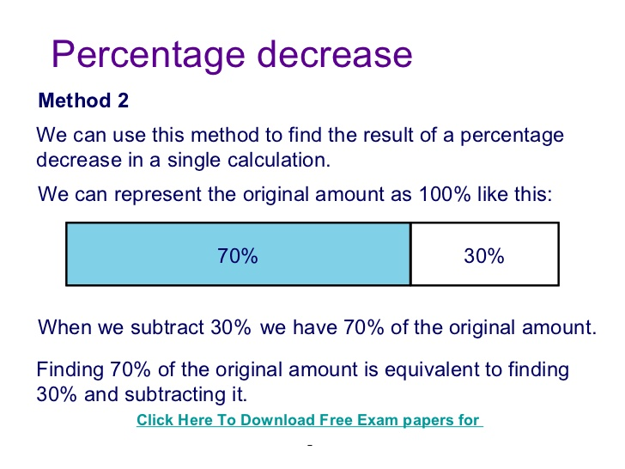

**Linear Vs. Exponential**

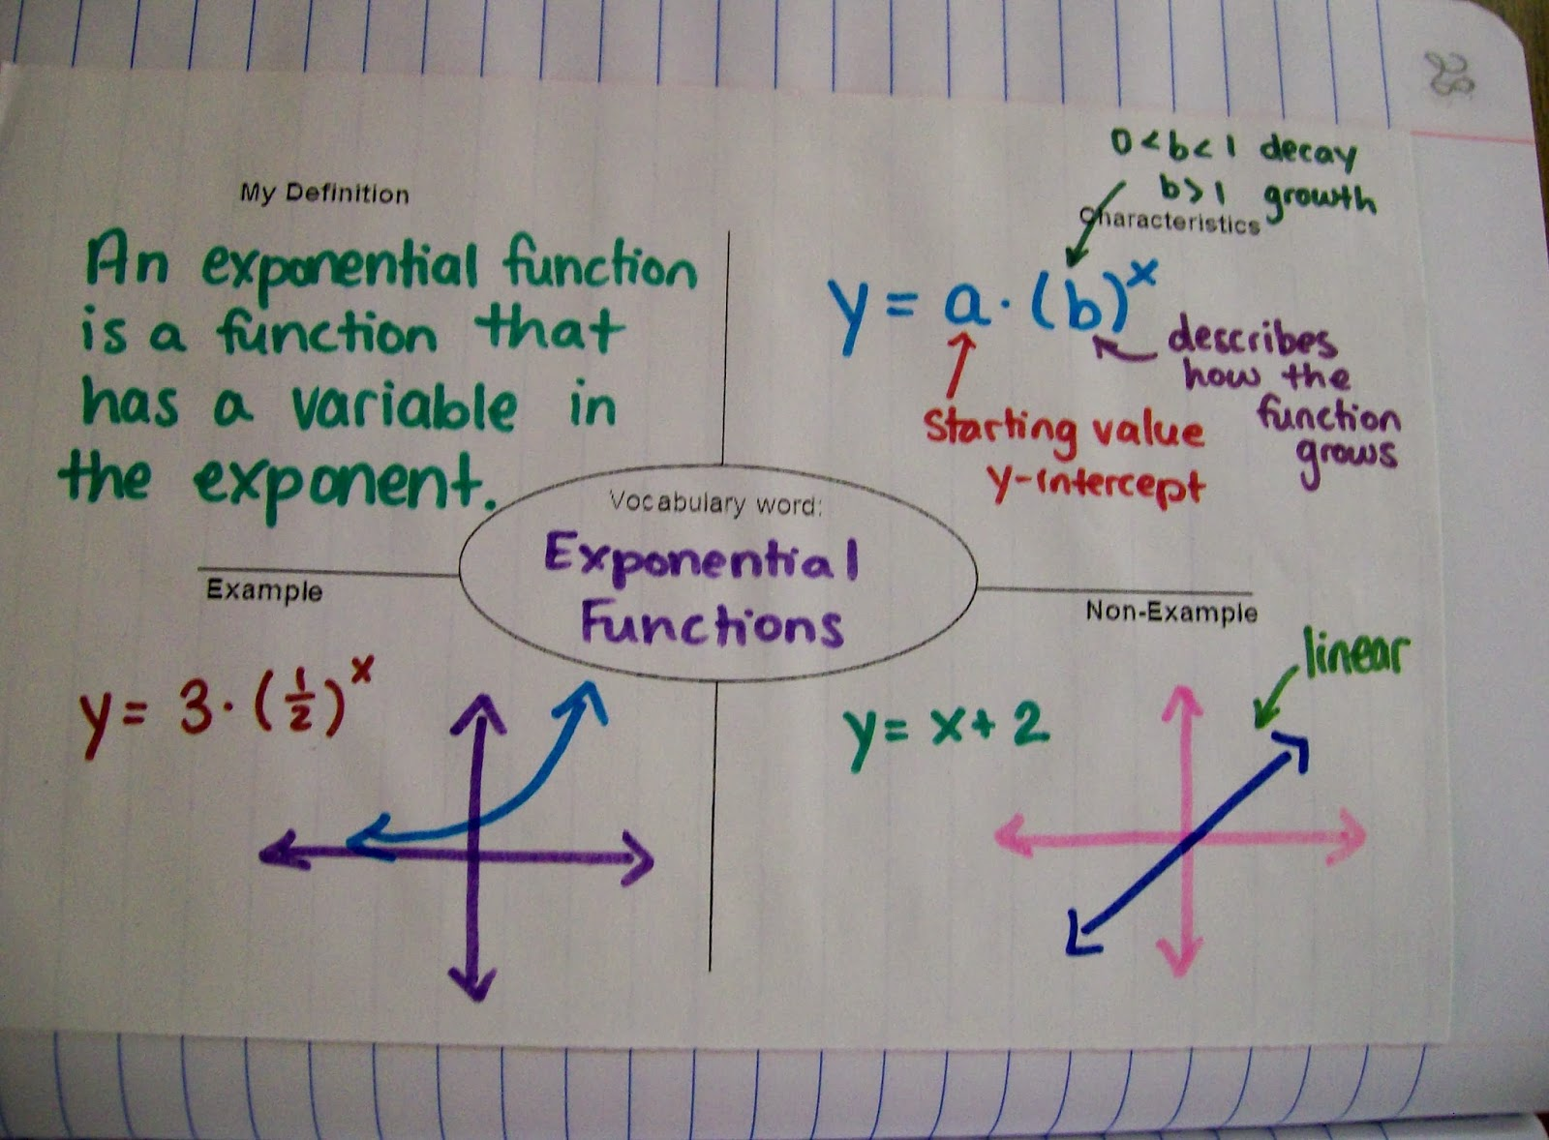

--The Set Up for an **Exponential Function** is**: a (b) x**

**a=** Represents the **initial value**

**b=** Represents the **growth rate**

**X=** Represents **the variable** (the exponent)

--The Set Up for an **Linear Function** is**: y=mx+b**

**m=** Represents the **slope**

**b=** Represents **the Y-Intercept**

**Arithmetic Sequences and equations (linear equations/set up)**

We were just talking about **linear vs, exponential equations**. These are very **similar to Linear Equations, Arithmetic Sequences involve Addition**, we call that the **Common Difference**. We just say addition, because you can add a negative number, for example, 8 + - 1 = 7 we added the negative one.

[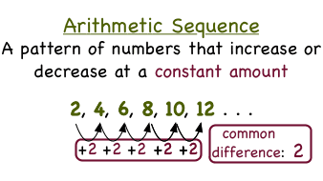](http://www.google.com/url?sa=i&rct=j&q=&esrc=s&source=images&cd=&cad=rja&uact=8&ved=0ahUKEwjqys267czZAhXCct8KHZDKBSgQjRwIBw&url=http://virtualnerd.com/algebra-2/sequences-series/arithmetic/arithmetic-sequences/arithmetic-sequence-definition&psig=AOvVaw2Y668FSfBOZDI9JK6RzXaf&ust=1520053125779285)

The **Common Difference on the left is 2.** That’s the “d” in the equation. **So we substitute d=2 into the equation.**

The **First Term is just the first number,** it also happens to be 2 here.That’s the “a1” in the equation. Then, **we substitute** a1=2 and “d’ into the equation.

The **Normal Set Up 🡪 an = a1+d(n-1)**

After **we substitute in** **a1 and d** 🡪 an =2 +2(n-1) = 2 +2n–2 = 2n

\***You may need to distribute and combine like terms! (PEMDAS…)**

**THIS IS THE NORMAL SET UP (Standard Equation)**

[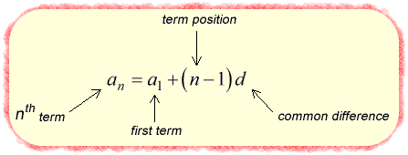](https://www.google.com/url?sa=i&rct=j&q=&esrc=s&source=images&cd=&cad=rja&uact=8&ved=0ahUKEwjrhtacl8XZAhVudt8KHeawB88QjRwIBw&url=https://www.chilimath.com/lessons/intermediate-algebra/arithmetic-sequence-formula/&psig=AOvVaw3U_QzmtQzyowz-0q3VAxO1&ust=1519789453879021)

Another example: For the sequence 3, 8, 13, 18, 23, … a1= 3, d= 5

The Normal Set Up 🡪 an = a1 + d (n-1)

After **we substitute in** **a1 and d** 🡪 an = 3 + 5 (n-1) = 3 + 5n – 5 = 5n -2

**Arithmetic Sequences and equations (graphs/table values)**

Linear equations form lines…..**THEY ALWAYS START AT ONE**

Arithmetic sequences **look like lines** on graphs also, **but we DO NOT CONNECT THE DOTS**

[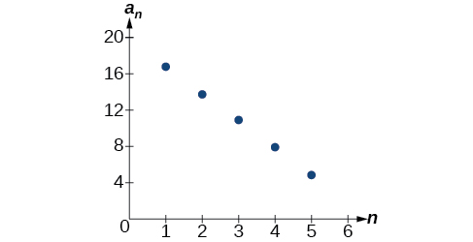](http://www.google.com/url?sa=i&rct=j&q=&esrc=s&source=images&cd=&cad=rja&uact=8&ved=0ahUKEwid_u338czZAhUMTt8KHV9YAtYQjRwIBw&url=http://philschatz.com/precalculus-book/contents/m49445.html&psig=AOvVaw1hzJAnjPQHOKEqaqu3kg1I&ust=1520054214425240)[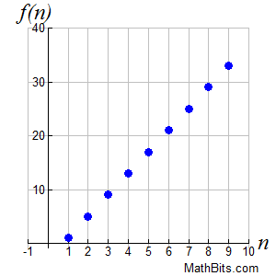](https://www.google.com/url?sa=i&rct=j&q=&esrc=s&source=images&cd=&cad=rja&uact=8&ved=0ahUKEwiHnNXf8czZAhVLTd8KHSoRAf0QjRwIBw&url=https://mathbitsnotebook.com/Algebra1/Functions/FNSequences.html&psig=AOvVaw1hzJAnjPQHOKEqaqu3kg1I&ust=1520054214425240)

[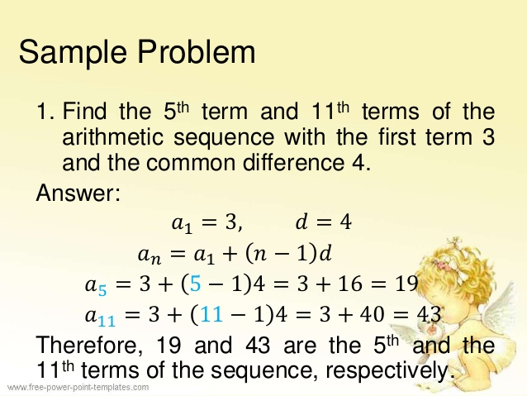](https://www.google.com/url?sa=i&rct=j&q=&esrc=s&source=images&cd=&cad=rja&uact=8&ved=2ahUKEwjLg7iEr9TZAhUDT98KHUVrCawQjRx6BAgAEAY&url=https://www.slideshare.net/maricelmas/arithmetic-sequence-55860724&psig=AOvVaw3FsO-JMNK4BWIMYNdz1Cap&ust=1520311279648195)

**Geometric Sequences** (Vs. Arithmetic Sequences)

Remember**, Geometric Sequences involve Multiplication** We just say multiplication, because you can multiply by the reciprocal (multiply the flip) instead of dividing, for example, 8 ÷ 2 = 4, but instead of dividing by 2, we can multiply by ½ (the flip), 8 x ½ = 4. We multiplied 8 by the reciprocal of 2 which is ½. We call the number we **Multiply by the Common Ratio**. In the formula, the **Common Ratio is “r”.**

[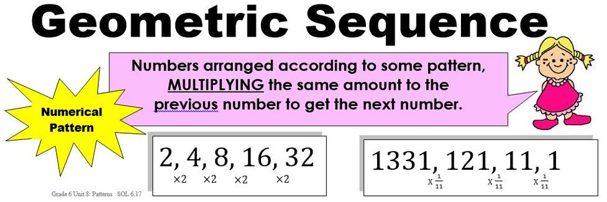](https://www.google.com/url?sa=i&rct=j&q=&esrc=s&source=images&cd=&cad=rja&uact=8&ved=0ahUKEwiKuvDvmMXZAhWEON8KHeT1CmoQjRwIBw&url=https://brms-math6.weebly.com/objective-617-geometric-and-arithmetic-sequences.html&psig=AOvVaw3U_QzmtQzyowz-0q3VAxO1&ust=1519789453879021)

Below is a visual of the difference, we look if we are adding or multiplying

[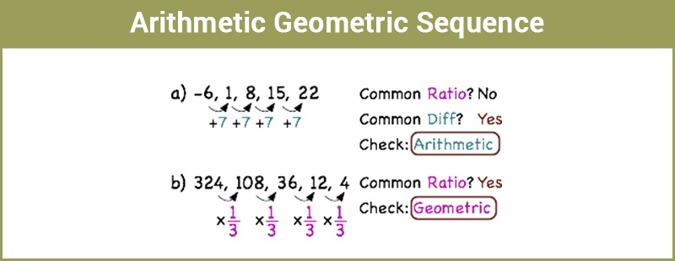](https://www.google.com/url?sa=i&rct=j&q=&esrc=s&source=images&cd=&cad=rja&uact=8&ved=0ahUKEwjlo5Xzl8XZAhXtlOAKHRSqCFkQjRwIBw&url=https://byjus.com/maths/arithmetic-geometric-sequence/&psig=AOvVaw3U_QzmtQzyowz-0q3VAxO1&ust=1519789453879021)

**Geometric Sequences (Formula/Set up)**

**THIS IS THE NORMAL SET UP (Standard Equation)**

[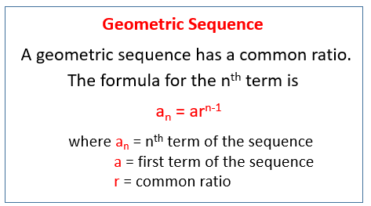](https://www.google.com/url?sa=i&rct=j&q=&esrc=s&source=images&cd=&cad=rja&uact=8&ved=2ahUKEwjE3_aVqNTZAhVymeAKHWGZAiUQjRx6BAgAEAY&url=https://www.onlinemathlearning.com/geometric-sequences.html&psig=AOvVaw0pqZ_ifLMidtLKVJhk9me-&ust=1520309436927786)

Another example: For the sequence 2, 6, 18, 56 … a1 = 2, r = 3,

The Normal Set Up 🡪 an = a1r(n-1)

After **we substitute a1 in** **r**  🡪 an = 2(3)(n-1)

*Remember, **PEMDAS, and Exponents are GLUED**

[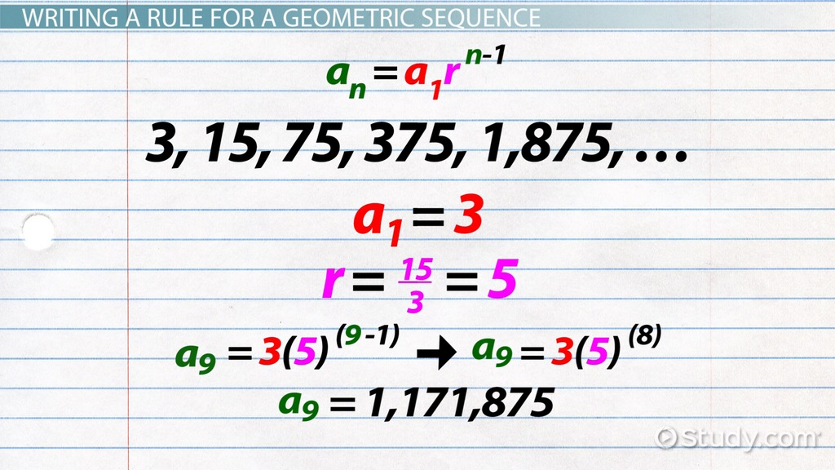](https://www.google.com/url?sa=i&rct=j&q=&esrc=s&source=images&cd=&cad=rja&uact=8&ved=2ahUKEwjBgIHBrtTZAhUwVt8KHSHYAm8QjRx6BAgAEAY&url=https://study.com/academy/lesson/geometric-sequence-formula-examples-quiz.html&psig=AOvVaw0jseNyZKGmD-boahJW2ZO8&ust=1520311118402856)